Brené Brown on How to Reckon with Emotion and Change Your Narrative
The most powerful stories may be the ones we tell ourselves, says Brené Brown. But beware—they're usually fiction.

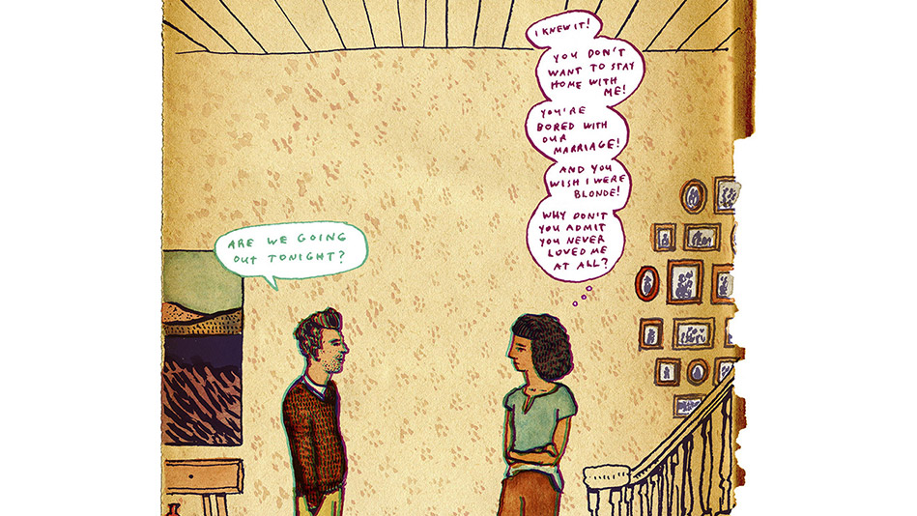

My husband, Steve, and I were having one of those days. That morning, we'd overslept. Charlie couldn't find his backpack, and Ellen had to drag herself out of bed because she'd been up late studying. Then at work I had five back-to-back meetings, and Steve, a pediatrician, was dealing with cold-and-flu season. By dinnertime, we were practically in tears.
Steve opened the refrigerator and sighed. "We have no groceries. Not even lunch meat." I shot back, "I'm doing the best I can. You can shop, too!" "I know," he said in a measured voice. "I do it every week. What's going on?"
I knew exactly what was going on: I had turned his comment into a story about how I'm a disorganized, unreliable partner and mother. I apologized and started my next sentence with the phrase that's become a lifesaver in my marriage, parenting and professional life: "The story I'm making up is that you were blaming me for not having groceries, that I was screwing up."
Steve said, "No, I was going to shop yesterday, but I didn't have time. I'm not blaming you. I'm hungry."
Storytelling helps us all impose order on chaos—including emotional chaos. When we're in pain, we create a narrative to help us make sense of it. This story doesn't have to be based on any real information. One dismissive glance from a co worker can instantly turn into I knew she didn't like me. I responded to Steve so defensively because when I'm in doubt, the "I'm not enough" explanation is often the first thing I grab. It's like my comfy jeans—may not be flattering, but familiar.
Our stories are also about self-protection. I told myself Steve was blaming me so I could be mad instead of admitting that I was vulnerable or afraid of feeling inadequate. I could disengage from the tougher stuff. That's what human beings tend to do: When we're under threat, we run. If we feel exposed or hurt, we find someone to blame, or blame ourselves before anyone else can, or pretend we don't care.
But this unconscious storytelling leaves us stuck. We keep tripping over the same issues, and after we fall, we find it hard to get back up again. But in my research on shame and vulnerability, I've also learned a lot about resilience. For my book Rising Strong, I spent time with many amazing people—from Fortune 500 leaders to long-married couples—who are skilled at recovering from setbacks, and they have one common characteristic: They can recognize their own confabulations and challenge them. The good news is that we can rewrite these stories. We just have to be brave enough to reckon with our deepest emotions.
In navigation, dead reckoning is how you calculate your location. It involved knowing where you've been and how you got there—speed, route, wind conditions. It's the same with life: We can't chart a new course until we find out where we are, how we came to that point and where we want to go. Reckon comes from the Old English recenian, meaning "to narrate." When you reckon with emotion, you can change your narrative. You have to acknowledge your feelings and get curious about the story behind them. Then you can challenge those confabulations and get to the truth.
I'll walk you through it. The next time you're in a situation that pushes your buttons—from a breakup to a setback at work—and you're overwhelmed by anger, disappointment or embarrassment, try this practice.
Engage with your feelings
Your body may offer the first clue that you're having an emotional reaction: for instance, your boss assigns the project you wanted to a colleague, and your face begins to feel hot. Or your response may involve racing thoughts or replaying the event in slow motion. You don't need to know exactly where the feelings are coming from: you just have to acknowledge them.
My stomach is in knots.
I want to punch a wall.
I need Oreos. Lots of them.

Get curious about the story behind the feelings.
Now you're going to ask yourself a few questions. Again, it's not necessary to answer them right off the bat.
Why am I being so hard on everyone?
What happened right before this Oreo craving set in?
I'm obsessing over what my sister said. Why?
This step can be surprisingly difficult. You're furious because Todd got the project, but it may feel easier to steamroll over your anger with contempt: Todd's a brownnoser. This company's a joke. Getting curious about your feelings may lead to some discoveries: What if you're more hurt than you realized? Or what if your attitude could have played a part? But pushing through discomfort is how we get to the truth.
Write it down.
The most effective way to become truly aware of our stories is to write them down, so get your thoughts on paper. Nothing fancy—you can just finish these sentences:
The story I'm making up...
My emotions...
My thinking...
My body...
My beliefs...
My actions...
For instance, you might write, I'm so peeved. I feel like I'm having a heatstroke. She thinks I'm incapable. I want to hurl a stapler.
You can be mad, self-righteous, confused. A story driven by emotion and self-protection probably doesn't involve accuracy, logic or civility. If your story contains those things, it's likely that you're not being fully honest.

Get ready to rumble.
It's time to poke and prod at your findings, exploring the ins and outs. The first questions may be the simplest:
1. What are the facts, and what are my assumptions?
I really don't know why my boss picked Todd. And I didn't tell her I was interested in the project—I figured she knew.
2. What do I need to know about the others involved?
Maybe Todd has some special skill or she has me in mind for something else.
Now we get to the more difficult questions:
3. What am I really feeling? What part did I play?
I feel so worthless. I'm failing in my career. And I don't want to ask for anything because someone might say no.
You may learn that you've been masking shame with cynicism, or that being vulnerable and asking for what you want is preferable to stewing in resentment. These truths may be uncomfortable, but they can be the basis of meaningful change.
Figuring out your own story could take 20 minutes or 20 years. And you may not make one big transformation; maybe it's a series of incremental changes. You just have to feel your way through.
If you're thinking this sounds too hard, I get it. The reckoning can feel dangerous because you're confronting yourself—the fear, aggression, shame and blame. Facing our stories takes courage. But owning our stories is the only way we get to write a brave new ending.

