CBT 5 PART MODEL
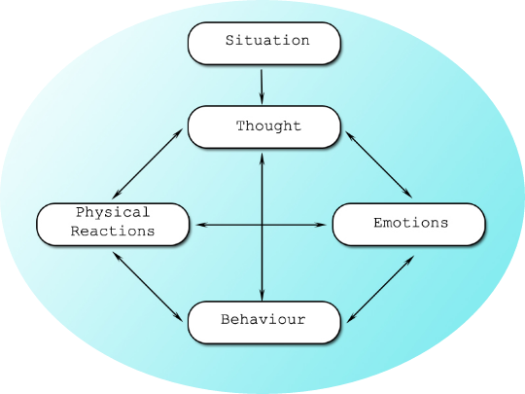
The model consists of 5 interlinking "parts". The Situation is the "who, what, when, where, why" element, it includes the environment that you find yourself in and gives rise to the thought.
e.g.: "I was out walking my dog at 8am yesterday morning when I saw Bob. I went to say "hello", but he walked straight past me without looking up".
From this you could have many Thoughts but for this example you think: "He didn't care to stop for a quick chat and was very rude"
- "Bob doesn't like me".
Our thoughts then interlink with our Emotions, thinking someone doesn't like you is negative in impact and could leave you feeling down, sad, rejected; use a single word to describe if possible.
Our thoughts/emotions share a close link to our Physical state. In this example we are thinking someone else doesn't like us and are feeling sad/down/rejected, our physical state may reflect this with slumped body language, general lethargy, teary eyes.
The final part of the model is Behaviour - what we do next from this situation. In this example this very negative mood state may cause us to go home, avoid a planned meeting with other friends later on and even avoid Bob's phone calls in the future.

Understanding your problem

Try to fill in something of your own experience. You may begin to understand your difficulties a little better; particularly what patterns may exists and how things interact:
SITUATION
FEELINGS
BEHAVIOUR
PHYSICAL REACTIONS
THOUGHTS

