COACHING PROGRESS REVIEW
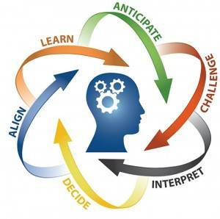
This short reflective piece is the opportunity for you to do some thinking before your next session that will help you look at day to day positives, challenges and how you are doing overall in the coaching work
1. What have I achieved since the last session/what things have gone well?

2. What challenges have I overcome?

3. What hasn't gone well since the last session and why? Where am I stuck?

4. What challenges lie ahead for me?

5. How am I doing in relation to the broad Coaching objectives I set at the start of the coaching work?

