Circle of Concern and Circle of Influence: Stephen Covey

What can you change? What can’t you change?
Covey describes the habit of being proactive with what he calls the circle of concern and the circle of influence.
The circle of concern: represents the degree of focus we spend dealing with our concerns such as our health, family and work related problems. The more time and energy people spend brooding or worrying about pressures over which they have no control, or complaining about barriers that they perceive they cannot overcome, then the more stressed and reactive they become.

The circle of influence: represents the degree of focus we place on doing things to influence some of our concerns. The more people focus on the things they can do something about and work on them, the more ‘pro-active’ and less stressed they become. As they do this, they increase their circle of influence.

Probably one of the best expressions of the habit of proactivity is Reinhold Niebuhr's famous serenity prayer, abbreviated as:
“God grant me the serenity to accept the things I cannot change, courage to change the things I can, and the wisdom to know the difference”

Exercise:

- Write down a specific aspect of work that is causing you pressure you would like to manage more effectively ……………………………………………………………………………………………………………………………………
Questions to fill in the circle of influence:
- What aspects of this pressure are you already influencing? What have you done in similar situations in the past? What strategies have other people used that you’ve noticed worked? What else could you do?
Questions to fill in the circle of concern
- What aspects of this pressure are you concerned about but cannot influence? Write them in the outer circle.
- Every time you write something in the outer circle ask yourself: ‘is there anything (even something small) I can influence about this concern?’
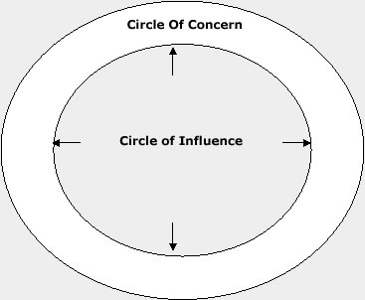

LEARNING LOG: PERSONAL DEVELOPMENT PLAN

To extend my circle of influence in this area of pressure, I will:

a)

b)

c)

d)

Whose support do you need to do this?

What does this support look like?

How are you going to ask them?

