The Door

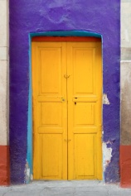

Go and open the door.
Maybe outside there’s
a tree, or a wood,
a garden
or a magic city.

Go and open the door.
maybe a dog’s rummaging.
Maybe you’ll see a face
or an eye,
or the picture
of a picture.

Go and open the door.
If there’s a fog
it will clear.

Go and open the door.
even if there’s only
the darkness ticking,
even if there’s only
the hollow wind
even if nothing is there,
go and open the door.

At least
there’ll be
a draught.

Miroslav Holub

