The wave and the iceberg

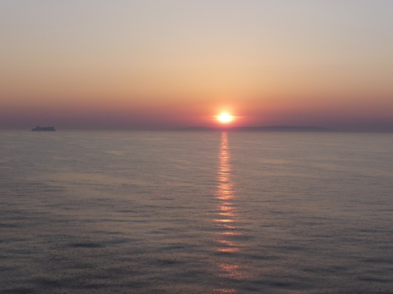

You get the days, maybe weeks, when life flows like a wave to the shore

With clear conviction, rising gradually, arced in forward momentum

Purposeful and knowing, direction set

Doing what it was meant to do.

Out of the corner of our eyes an iceberg approaches

(Or maybe we hit it in the middle of the night, surprised that it's there)

Size dependent: a misunderstanding, a fall out, a meeting badly handled, feeling wronged

And we run to the wheel to change course, avoid sinking into

The dark swirling water that will engulf us and send us to the ocean floor

Maybe we can divert course, repair the damage caused

Sail on and make repairs on the run

Take time out to reflect and realise what went wrong

Be kind, forgive our own or others wrongdoing

But every so often, the ship sinks, crashes to the bottom

And this pain, a negative black Taj Mahal opposite the white one never built

That isn't exhilaration but agonising

That isn't dancing in the moment but contorted freeze frame

By staying with it cleanses and makes us anew, shows us the unutterable truth of fragility

Seeps into our muscles the ultimate lessons of life: love and learning.

So, yes, ride the wave, feel the surf spray exultantly sting your cheeks

Savour the bubbling joy of fun, intimacy, and the eternal beauty of the universe

Avoid the icebergs when you can and the damage is light

But know that to be human is to feel pain that will find you, claim you

That the joy of existence takes its genesis from the same well as the pain of sadness

And that hope can always be re-claimed.

