Neuroplasticity: Changing our Belief about Change

--by Joanna Holsten, syndicated from letslivenice.com, Apr 23, 2012

A dangerous belief in our culture is that we can't change. We’ve all heard the disempowered statements: “He’s just grumpy. He can’t change that.” or “I will always be anxious. It's the way I was born.” While we most certainly have genetic predispositions, the brains of individuals’ young and old can change in amazing ways.

Neuroplasticity is a fancy way of saying that our brains can change. We are not victims of our neurons or genes. We are empowered creators of our mental states. The erroneous belief that we are "set in stone" can stop people from trying to change and take away their responsibility. In the same way that germ theory altered the way we look at sanitation and hygiene, I think that spreading the knowledge about our brain’s ability to change can alter the way our culture approaches emotions, attitudes, and values.

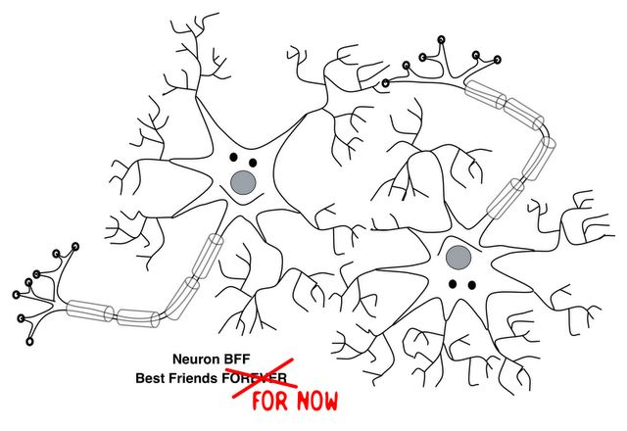

Our brains can change.

Our brains are made up of billions of neurons. Neurons connect to one another, forming pathways that relay information. We learn things by forming neural connections in response to associations in our everyday experiences. In learning to drive a car, we experience the connection between red traffic lights and pressing the brake. We form a neural pathway for this association. Each time we brake at a red light, we reinforce and strengthen the neural pathway. As the saying goes, "Neurons that fire together, wire together." The more we practice something, the more we strengthen the pathway, and the easier the skill becomes. Our behavioural response can become almost automatic.

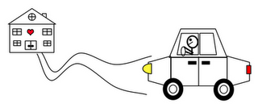Our brain can also prune old neural pathways to quiet or unlearn associations. For example, after you move to a different home, you learn the directions to your new place and stop practicing your old path. But in those first few weeks after a move, have you ever found yourself engrossed in another thought and accidentally pulling into the driveway of your old home because your automatic pathway took over? Luckily, by refraining from the old directions and practicing the new way home, you strengthen a new neural pathway and the old neural pathway weakens. It's a good thing our brains can change, or we would still be pulling up to our childhood home.

Similar to physical skills like driving, the brain also forms neural pathways in learning and practicing emotional skills. Your emotional responses to experiences in your world are the result of well-worn neural pathways that developed over your lifetime. While our genes influence our temperament, research has demonstrated that our environment and our own mind can physically alter our brains and thus our emotional responses. This means that emotions that we want more of in our life and our world, like happiness, patience, tolerance, compassion, and kindness, can be practiced and learned as skills. Other emotions, like anxiety, stress, fear, or anger, can be dampened.

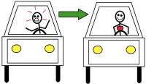Keeping in the car motif, let’s talk about an emotional association: traffic and anger. When we get stuck in traffic, an automatic response can be anger or frustration. But, by feeling angry every time we are in traffic, we are strengthening that neural pathway and cementing that emotional response. When there is nothing we can do in that moment but accept the traffic, wouldn’t it be great to feel positive emotions instead? We can just observe the negative emotion that we are feeling and try practicing a different emotional response. We can start linking traffic with stillness and peace. This would be difficult at first because we want to let the well-developed neural pathway leading to anger fire, but by inhibiting that pathway, we help unwire those connections and strengthen a different response. As we practice responding with peace, we strengthen a new neural pathway and it becomes easier to choose.

Using neuroimaging, researchers have demonstrated significant success in reducing anxiety, depression, phobia, and stress with cognitive-behavioural therapy or interpersonal psychotherapy. By learning different strategies to recognize negative thoughts and emotions and practice alternative responses over time, neural pathways in the brain are physically altered. Science has only recently recognized the value of investing in research on behaviors that promote well-being, including compassion and happiness. By comparing the brains of experts and novices in compassion meditation, neuroscientists illustrated changes in the brain region responsible for empathy during and after meditation. Researchers are just beginning to examine the effect of training novices in skills to increase compassion. While interventions have demonstrated positive impacts on emotional states and prosocial behaviours, we look to future studies to determine alterations in the structure and function of the brain in novices who undergo contemplative and emotional training.

Let's learn and practice compassion, kindness, and happiness.

Knowing that our brains can change, we then ask, what do we want in our brains? And as a result, what do we want in our world? Most people of good will yearn for happiness, compassion, and love. Let’s start practicing.

Gratitude reflections, compassion priming, and meditation interventions are some strategies found to enhance well-being and increase prosocial behavior. Several studies have shown the positive impact of gratitude journals, which involve self-guided listing of what you are thankful for. Individuals who kept a daily gratitude journal reported higher levels of positive emotions, including feeling attentive, determined, energetic, enthusiastic, excited, interested, joyful, and strong, compared to individuals who kept a journal on daily hassles or ways in which one was better off than others (downward social comparison). In addition, individuals who maintained daily gratitude journals were more likely to offer emotional support to others and help someone with a problem. Contemplative interventions, born from the collaboration of meditation traditions and emotion science, have centred on developing mindfulness to enhance compassion and happiness in the lives of individuals. One recent study provided an 8-week training program in secular meditation to female schoolteachers and measured their responses to stress, conflict, and compassion. The intervention significantly reduced rumination, depression, and anxiety while increasing mindfulness, empathy, compassion, and stabilizing hostility and contempt compared to a control group6.

In my experience, learning about the concept of neuroplasticity and finding the skills to change my emotional responses has immensely improved my life. Before grasping this, I thought my mind was a black box. I didn't understand why I felt certain things beyond the immediate external circumstances. I had no idea how to change things. You don't even have to know where to start; the decision to change is enough. The practice of meditation gave me the set of skills to guide my own transformation. It has been the most life altering skill that I have gained. I shifted from thinking that my emotion and thoughts owned me to feeling like I could play a role in changing my state. This is challenging work and takes patient practice, but as I am experiencing the fruits of these skills, peaceful relationships, a joyful outlook on life, and a safe harbour within myself during difficult times, I am determined to work even harder.

Neuroscience, positive psychology, and contemplative traditions have given us a roadmap. We know our brains can change based on our environment and our behaviours. What if we started building and reinforcing the neural pathways of love, cooperation, forgiveness, and kindness so that these things became our automatic response? What if we adopted and shared this belief that we can change and took responsibility for our outlook on life? What if we taught children in schools about their ability to reflect on and guide their emotions? What if we started priming those around us in our families and community with our own grateful reflections and kind actions? What if our compassionate actions in schools, families, and communities started shifting our culture? I find these possibilities exhilarating and hopeful. By learning and practicing these positive emotional responses, I think our world can discover a new way home and pull into the driveway of compassion.

Thank you to D. Scott Brown for reading several drafts.

