COACHING RE-FRAMING EXERCISE

STEPS | QUESTIONS TO ASK YOURSELF | NOTES/REFLECTIONS
Step 1: Identify the Problem | - What problem am I facing?  - What unhelpful behaviour am I indulging in?  - What limiting state-of-mind am I experiencing?
Step 2: Challenge Your Assumptions  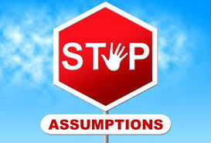 | - What is valuable and useful about this assumption I am making?  - What is useful about how I’m currently framing things?  - What is unhelpful about the assumption I am making?  - What is unhelpful about the way I’m framing things?  - Is there any evidence that goes against this assumption?  - Am I using any rules that could be challenged?  - How else could I interpret this experience?  - What else could this possibly mean? How could that be helpful?
Step 3: Re-frame Your Circumstances  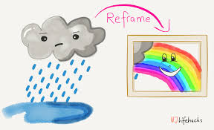 | - Is this really a problem, or is it a problem because of the way I feel about this situation?  - How would I deal with this situation if I were a scientist? Lawyer? Child? Man? Woman? Harry Potter?  - What would someone I admire do in this situation?  - What if this problem was part of a cartoon? How would the cartoon characters solve this problem?  - How would I approach this situation if I only had a day to solve it? How about an hour? How about a minute?  - What would other people do in my situation to help resolve this problem?  - What would I do right now if I knew I couldn’t fail?  - What is funny about this problem that I hadn’t noticed before?
Step 4: Test the Reframe | Now, have a think about your new behaviour/approach/perspective and complete the following statements:  - [new perspective] allows me to…  - [new perspective] provides me…  - [new perspective] helps me to…

