XXXX’s HEALTH CHECK 2019

 | 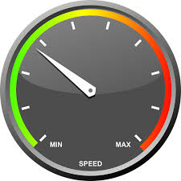  Making space for myself/self-care/de-cluttering and simplifying | 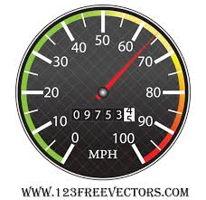  Holding boundaries with others/speaking out | Not working too hard; leaving in good time/cutting back hours | Freedom, fun and taking some risks
What rating would I give myself 1-10?

What's going well in this area?

What's not going well in this area?

How would I rate my overall progress over the last few months?

