The Healthy Mind Platter

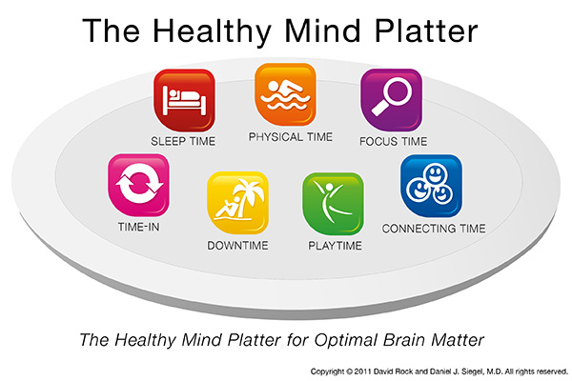

Seven daily essential mental activities to optimize brain matter and create well-being
Focus Time | When we closely focus on tasks in a goal-oriented way, we take on challenges that make deep connections in the brain.
Play Time | When we allow ourselves to be spontaneous or creative, playfully enjoying novel experiences, we help make new connections in the brain.
Connecting Time | When we connect with other people, ideally in person, and when we take time to appreciate our connection to the natural world around us, we activate and reinforce the brain's relational circuitry.
Physical Time | When we move our bodies, aerobically if medically possible, we strengthen the brain in many ways.
Time In | When we quietly reflect internally, focusing on sensations, images, feelings and thoughts, we help to better integrate the brain.
Down Time | When we are non-focused, without any specific goal, and let our mind wander or simply relax, we help the brain recharge.
Sleep Time | When we give the brain the rest it needs, we consolidate learning and recover from the experiences of the day.

The Healthy Mind Platter Overview
The US Department of Agriculture (USDA) recently replaced its food pyramid with a needed revision, a "choose my plate" pictorial example of a dish of food groups to remind us of what a daily diet should consist of to optimize physical health. What would be the equivalent of a recommended daily diet for a healthy mind?
With an obesity epidemic rampant in the US, this change is welcome and hopefully will inspire people to be aware of how they compose their day’s food intake. Our mind, embodied in our extended neural circuitry and embedded in our connections to others and even the way we relate to our planet, is also in need of careful attention to establish and maintain mental health. Poverty, hunger, and homelessness threaten the essential needs of many throughout the world. War and natural disasters fill many lives with fear and suffering. And even for individuals in more stable environments, modern life can be filled with an overwhelming focus on the outer world and an experience of being isolated from meaningful connections with others. Multi-tasking with its fragmented attention and the sense of becoming overwhelmed with information overload frequently fracture a sense of wholeness. In each of these conditions, the embodied and socially embedded requirements for a healthy mind are not being created in daily life throughout the world. Many are deficient in a daily regimen necessary for mental well-being.
So what would be included in The Healthy Mind Platter? In the field of interpersonal neurobiology, we define a core aspect of the mind and also propose that a healthy mind emerges from a process called “integration”— the linkage of different components of a system. That system can be, for example, the body as we connect upper and lower regions to one another. Integration can also include how we connect with others in a family or a community, honouring differences and promoting compassionate linkages with each other. If we embrace interpersonal neurobiology’s proposed definition of a key facet of mind as an embodied and relationally embedded process that regulates energy and information flow, how can we make a practical definition of mental habits that can help people with their diet of “daily essential mental nutrients”? How can we use the focus of attention to strengthen integration in our bodies and in our relationships on a daily basis? What would the fundamental components of such a health-promoting daily regimen of mental activities be?

To address these questions, my friend and colleague, David Rock, a leader in the organizational consulting world, and I got together and created what we're calling The Healthy Mind Platter. Here is how we describe the elements of this plan for a healthy mind.
The Healthy Mind Platter has seven daily essential mental activities necessary for optimum mental health. These seven daily activities make up the full set of “mental nutrients” that your brain and relationships need to function at their best. By engaging every day in each of these servings, you promote integration in your life and enable your brain to coordinate and balance its activities. These essential mental activities strengthen your brain's internal connections and your connections with other people and the world around you.
We're not suggesting specific amounts of time for this recipe for a healthy mind, as each individual is different, and our needs change over time too. The point is to become aware of the full spectrum of essential mental activities, and as with essential nutrients, make sure that at least every day we are bringing the right ingredients into our mental diet, even if for just a bit of time. Just as you wouldn't eat only pizza every day for days on end, we shouldn't just live on focus time alone with little time for sleep. The key is balancing the day with each of these essential mental activities. Mental wellness is all about reinforcing our connections with others and the world around us; and it is also about strengthening the connections within the brain itself. When we vary the focus of attention with this spectrum of mental activities, we give the brain lots of opportunities to develop in different ways.
One way to use the platter idea is to map out an average day and see what amounts of time you spend in each essential mental activity. Like a balanced diet, there are many combinations that can work well.
In short, it is important to eat well, and we applaud the new healthy eating plate. As a society we are sorely lacking in good information about what it takes to have a healthy mind. Since the mind is both embodied and embedded in our connections with others and our environment—both natural and cultural—these seven essential times help strengthen our internal and relational connections. And since the brain is continually changing in response to how we focus attention, we can use our awareness in ways that involve the body and our connections to create a healthy mind across the lifespan! We hope that The Healthy Mind Platter creates an appetite for increasing awareness of how to nourish our mental well-being each day too.

The Healthy Mind Platter was created by Dr. Daniel J. Siegel, Executive Director of the Mindsight Institute and Clinical Professor at the UCLA School of Medicine in collaboration with Dr. David Rock, Executive Director of the NeuroLeadership Institute.

